**OS LAB ASSIGNMENT**

**SCHEDULERS**

**SUBMITTED BY: MUNEEB IQBAL(SP22-BCS-030)**

**QUES#1**

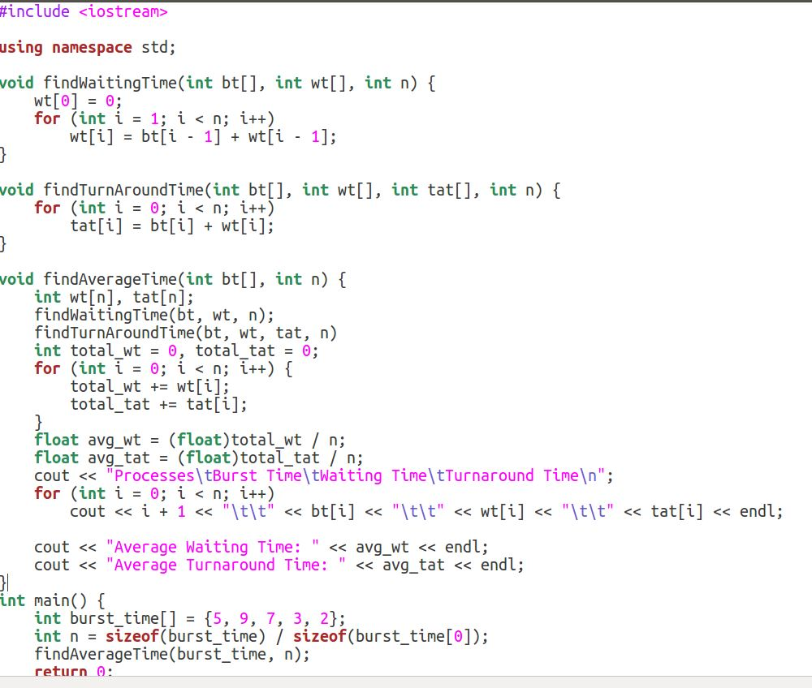

**OUTPUT**

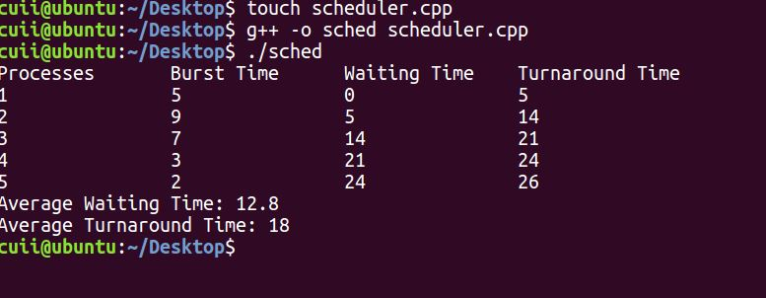

**QUES#2**

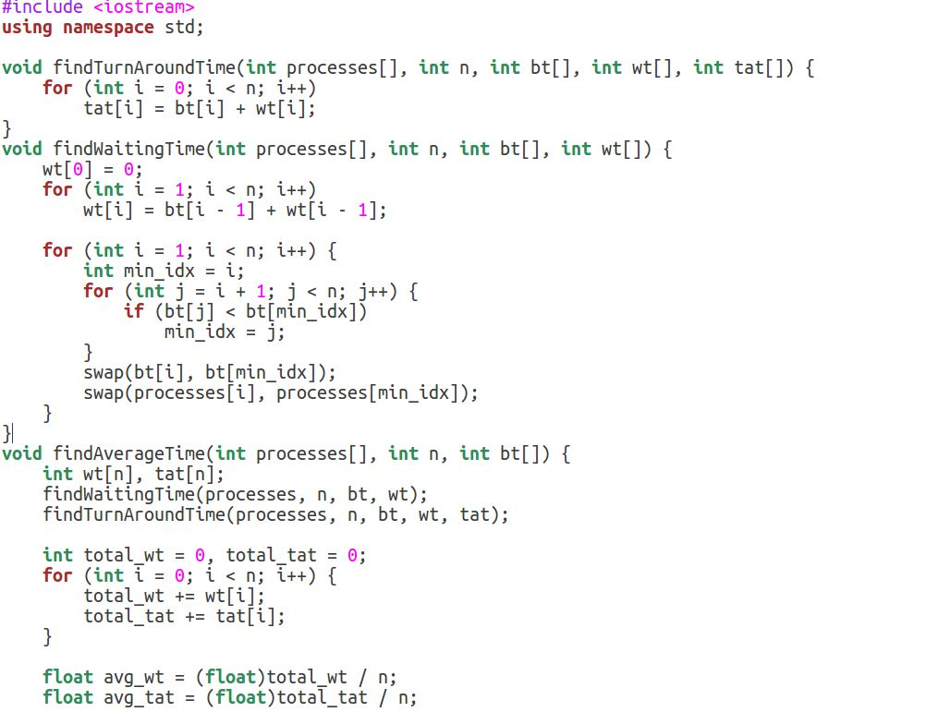

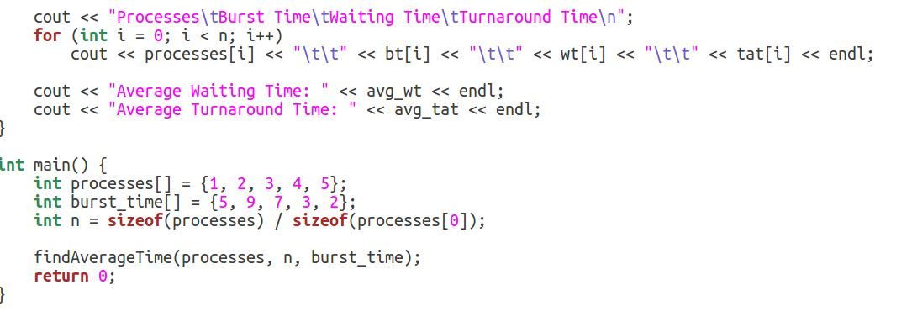

**OUTPUT**

